|  |  |
| --- | --- |
| Date | 4th November 2022 |
| Team ID | PNT2022TMID23198 |
| Project Name | Personal Expense Tracker |

Sprint 3

Steps:

1. **Create Log Today Module(add expense and add income)**

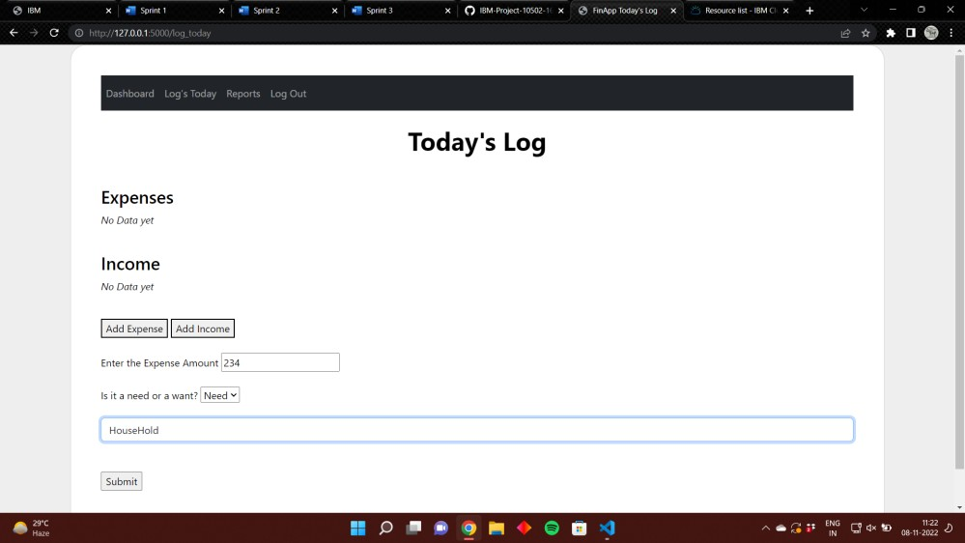

1. **Create Reports Module**

